
Department of CSE

B.Tech. CSE Trimester -5

Roll Number:2520030331
Name: Arnav Chitikena

Cloud Infrastructure and Services
25CS2206E

LAB RECORD
2026

Experiment -1

AIM: To create an AWS free tier account to provision the resources.

Description:
Amazon Web Services (AWS) is a cloud computing platform that provides various services such as computing, storage, databases, networking, and security over the internet.
AWS Free Tier allows new users to explore and learn AWS services by providing free usage allowances for eligible services. By creating an AWS account, users can access the AWS Management Console and provision cloud resources such as EC2 instances, S3 buckets, and databases.

Steps to Create an AWS Account
- Open the AWS official website.
- Click on Create Free Account.
- Enter your email address and AWS account name.
- Verify your email address using the OTP sent by AWS.
- Create a strong password for your AWS account.
- Select the appropriate account plan.
- Enter your personal details, including name, address, and phone number.
- Provide payment information for verification, if requested.
- Complete phone number verification using the OTP.
- Select the Basic Support Plan.
- Review the details and complete the registration.
- Wait for AWS to activate your account.
- Open the AWS Management Console.
- Sign in using your registered email address and password.
- The AWS account is now ready to provision and manage cloud resources.

Output:
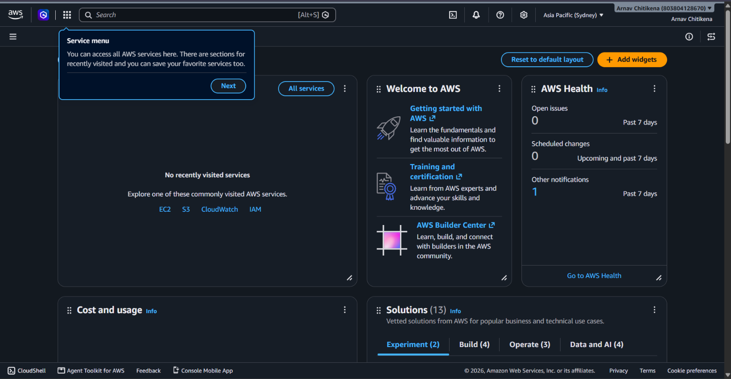

CREATING AN IAM USER

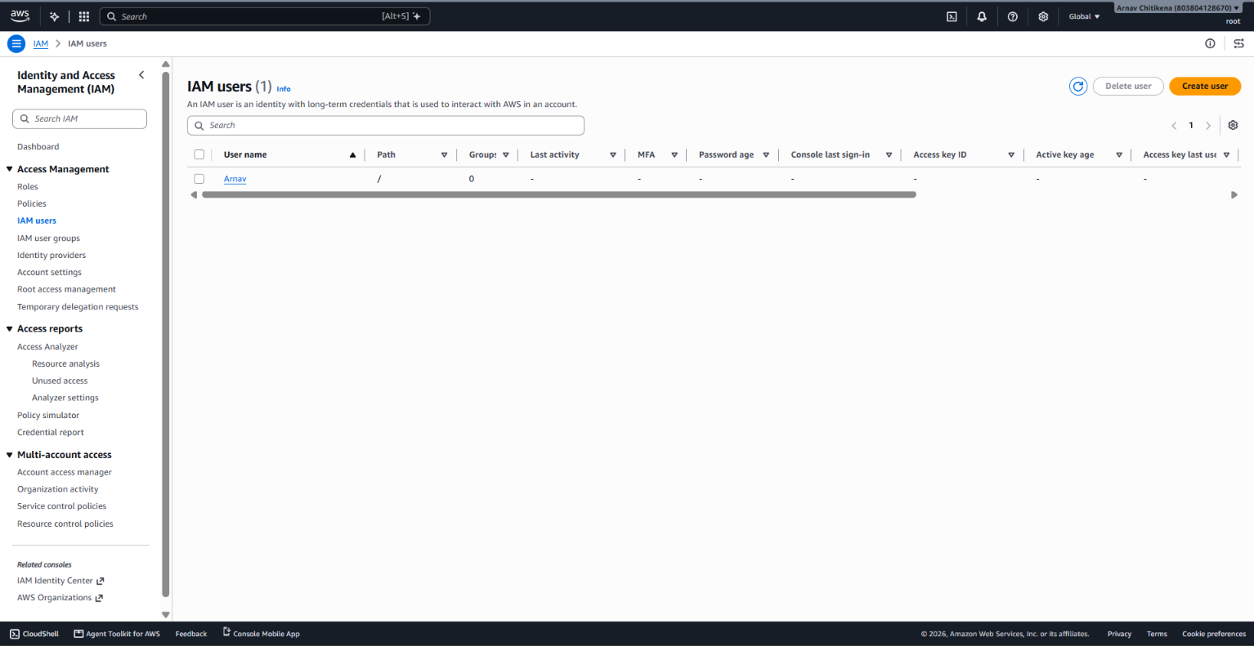
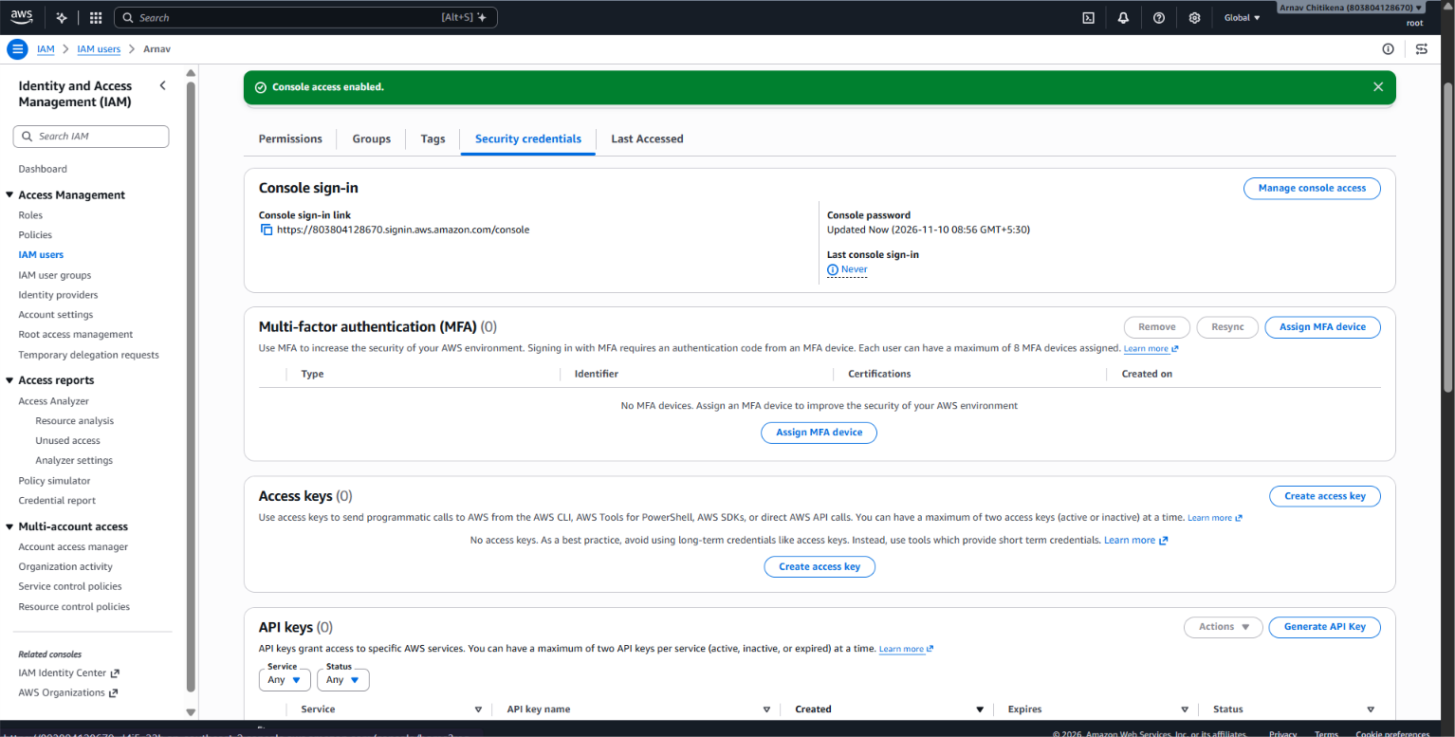
- Sign in to the AWS Management Console.
- Search for IAM.
- Select Users from the left navigation panel.
- Click Create user.
- Enter the username as Arnav.
- Enable Provide user access to the AWS Management Console.
- Select the password option.
- Click Next.
- Select Attach policies directly.
- Search for AdministratorAccess.
- Select the checkbox beside AdministratorAccess.
- Click Next.
- Review the username and permissions.
- Click Create user.
- Save the console sign-in URL and password securely.
- Sign in using the newly created IAM user credentials.

Created a access key username Arnav
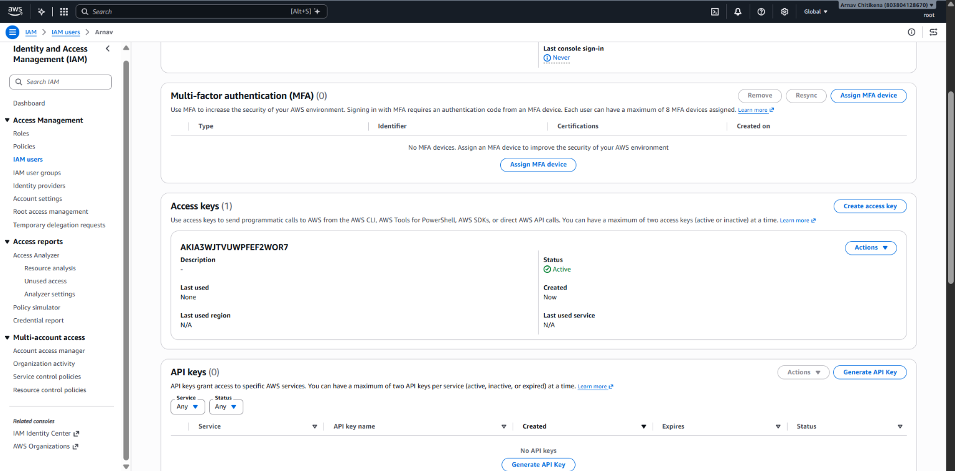
CREATING A NEW ONE OF THE GIVING PROGRAMMATIC ACCESS AND GIVING ZERO BUDGET
1. Create an IAM user with programmatic access only, download the access key and secret key, and document the steps with screenshots.Then set up a billing alert for the account so that an email is received when the Free Tier limit is about to be crossed.

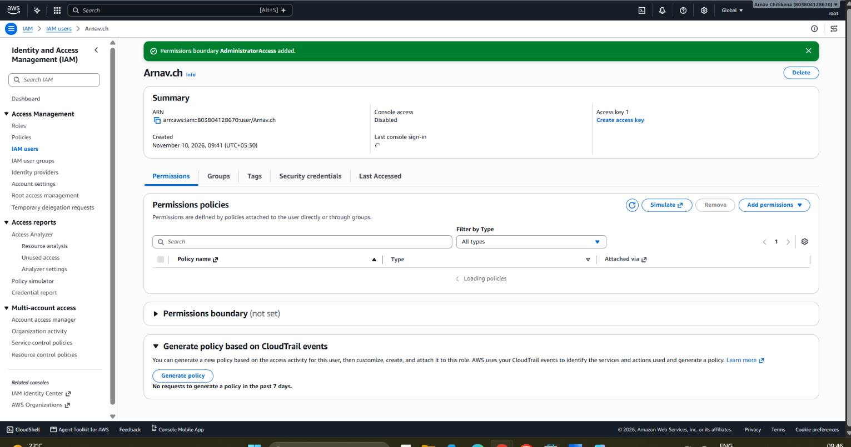
Created a new user and gave the following administrator access
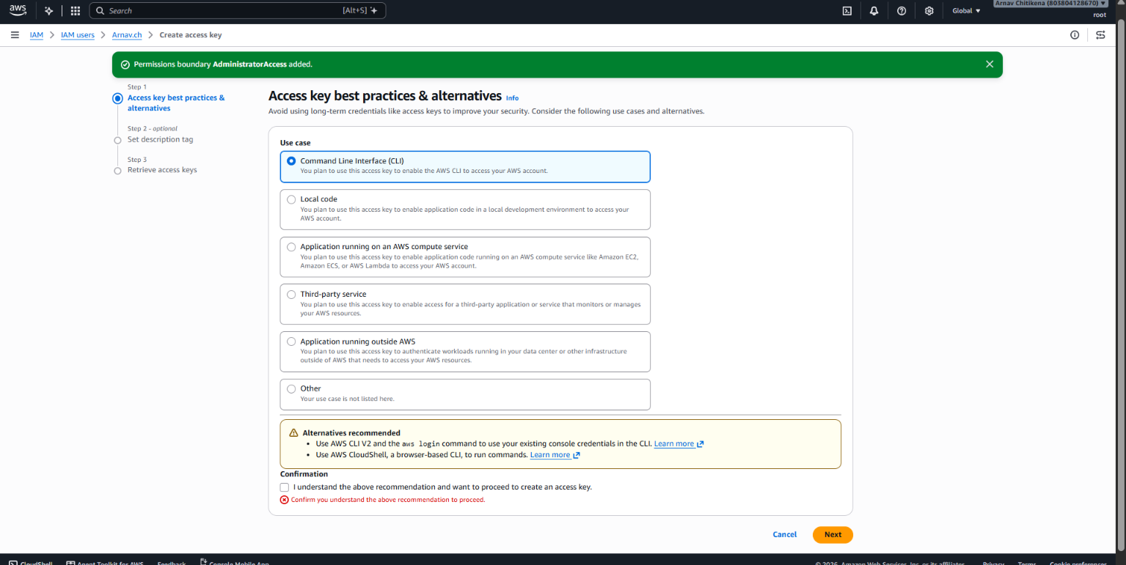
Giving which type of the Access

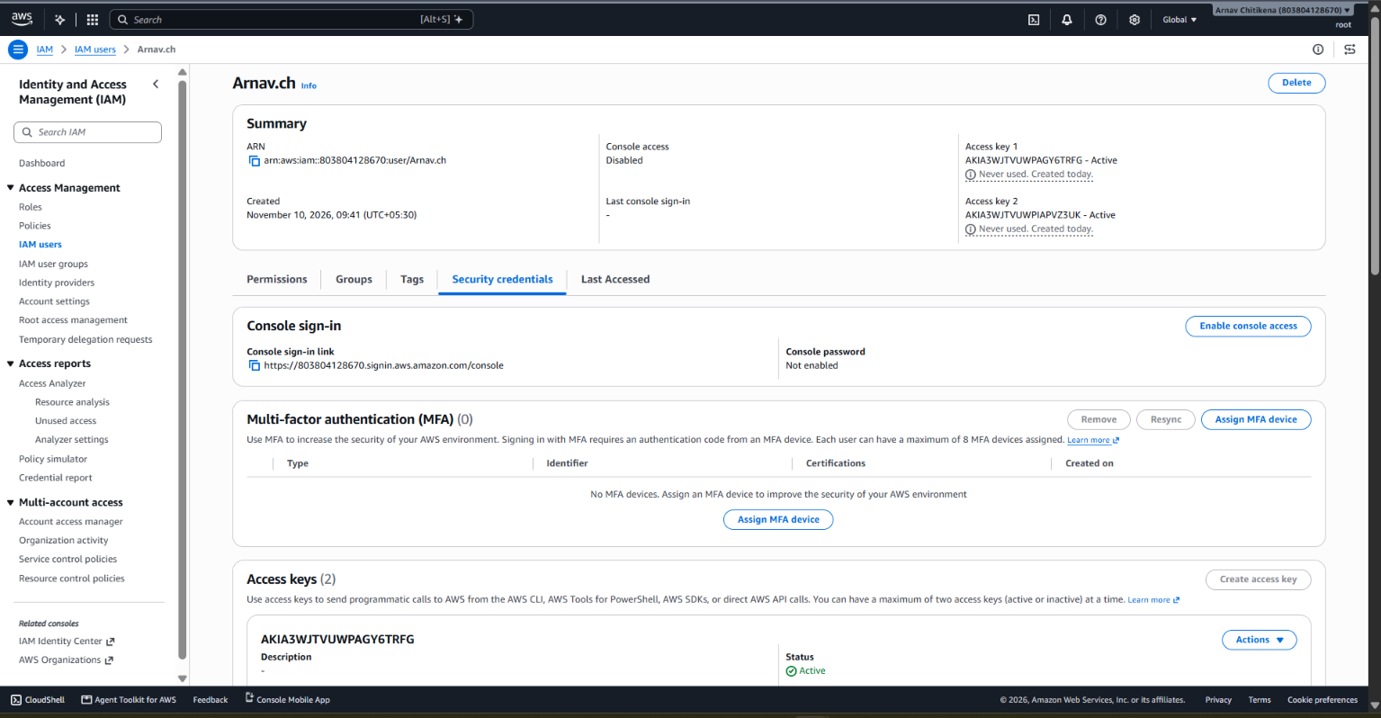
Created the accesskey

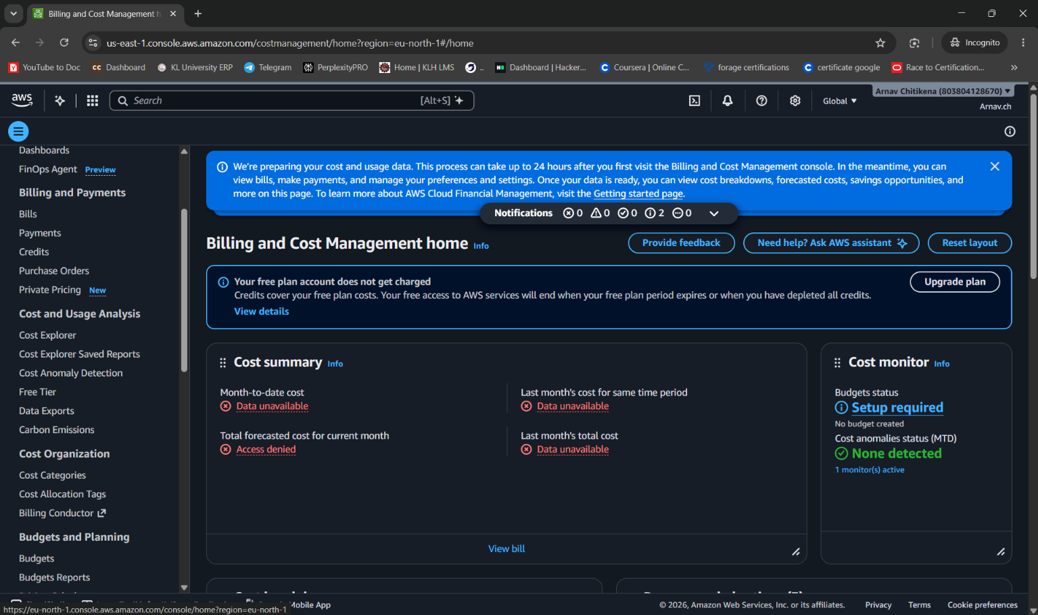
Signed into the new user which is created
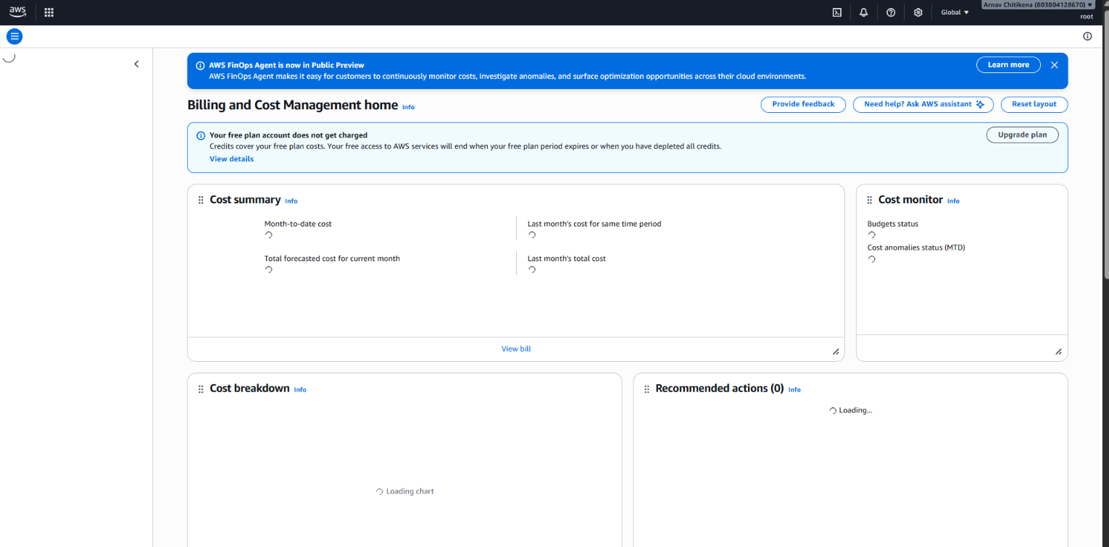
Proceeding to the billing and cost management
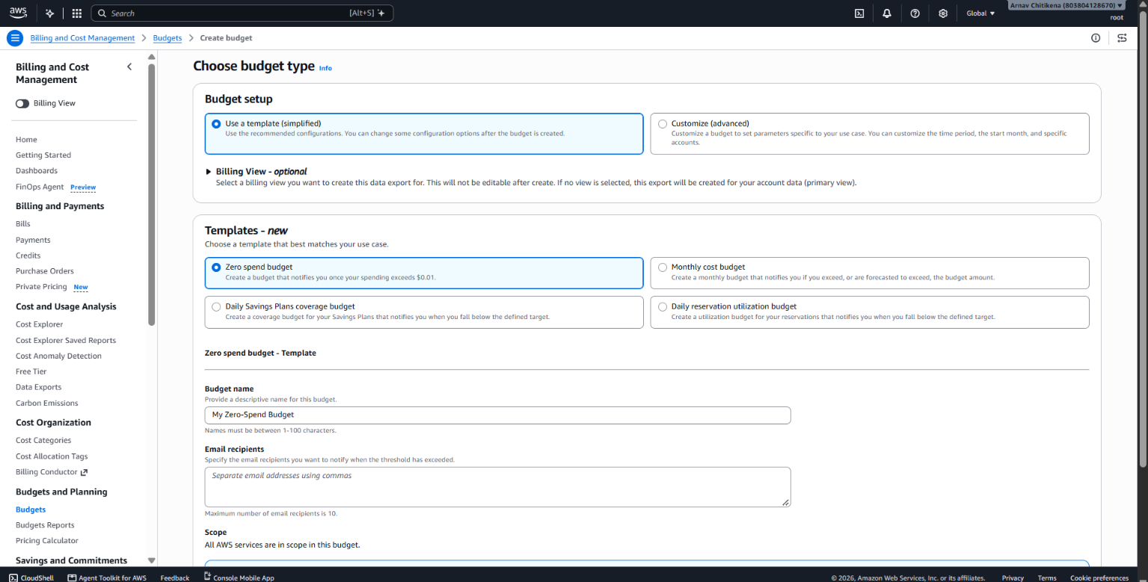
Selecting the budget as zero budget because to avoid the cost and setting a limit to it
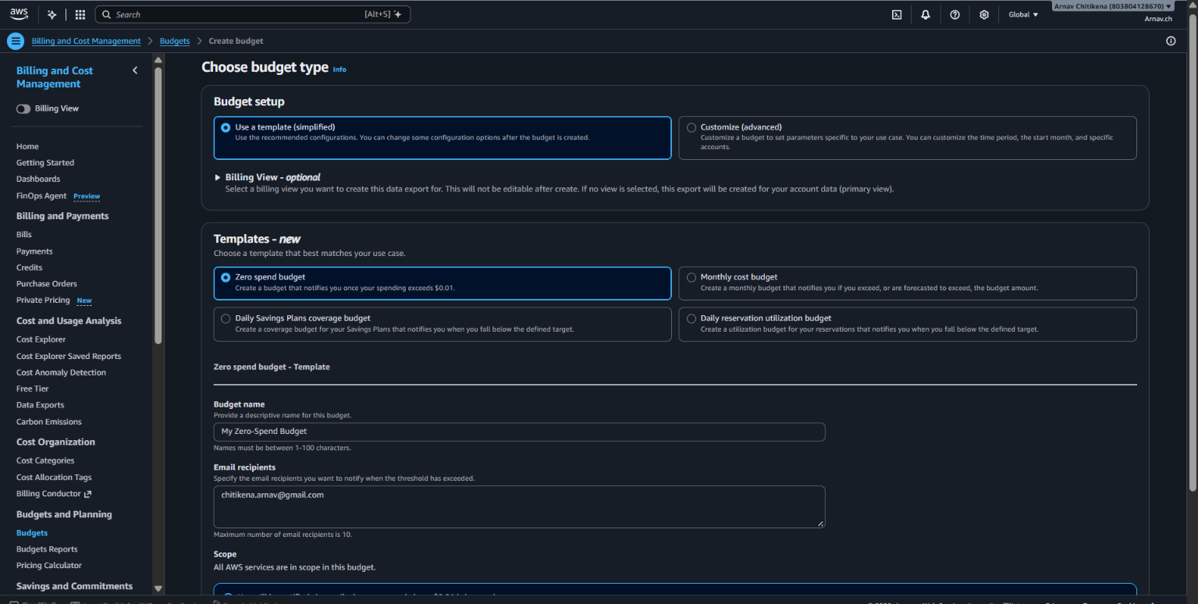
The budget has been created to the new user named Arnav.ch

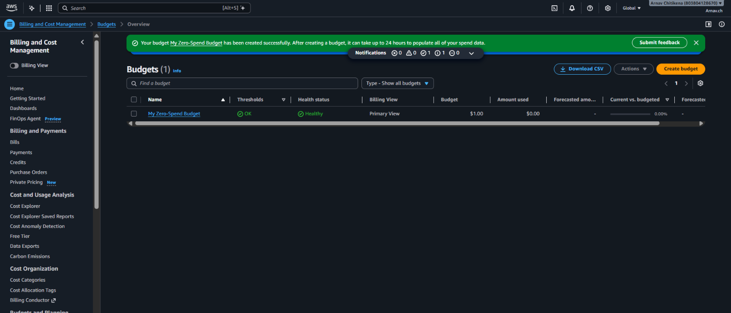

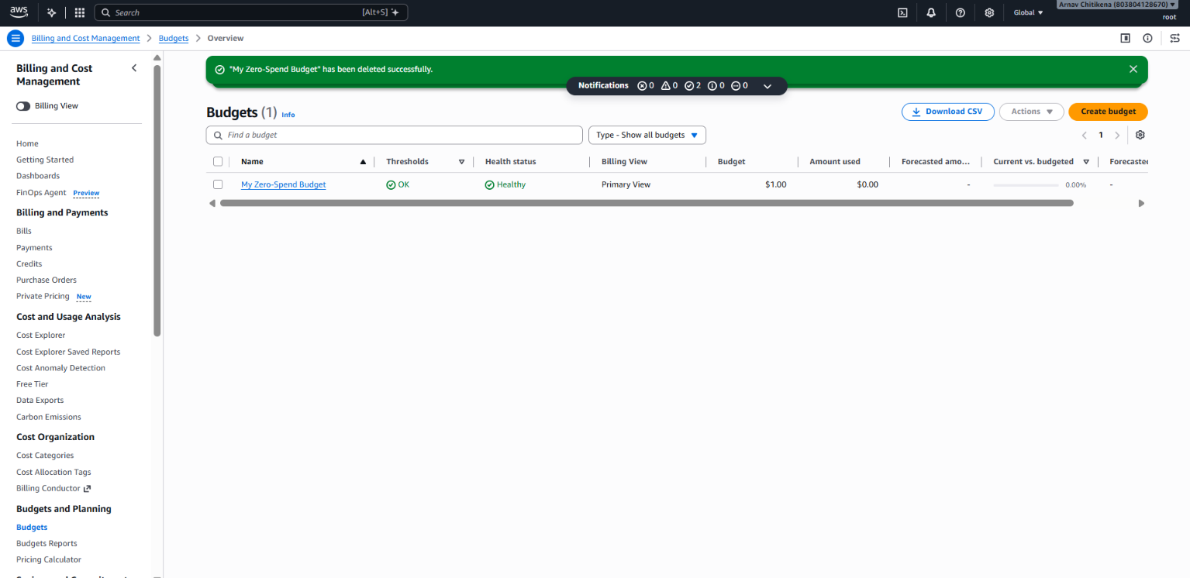
Now created the for the budget for the new root user

Steps:
- Sign in to AWS using the Root User and navigate to Billing and Cost Management → Budgets.
- Click Create budget, select Zero spend budget – Template, and enter the budget name and email address.
- Verify the details and click Create budget to receive spending notifications via email.

